1. Shadcn already provided us with the dark theme and light theme codes in our global CSS file.
2. So, to leverage that we first install the next themes library.



1. Then in our global layout, we imported the provider



And then wrapped our child with it

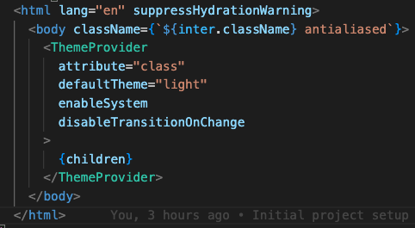

* Here we use the suppress Hydration because next themes use window under the hood and server and client misalignment causes errors in the console

1. Now, we install the dropdown menu from shadcn



1. And make the toggler component out of it, and there we have it: our working theme toggler.

